
About this Handbook
This handbook serves as the official reference for all enrolled Candidates in the Weatherford College Educator Preparation Program (WC EPP) and the Bachelor of Applied Arts and Sciences in Early Childhood Education and Teaching (BAAS ECET) program. It outlines the program’s academic structure, certification pathway, professional expectations, fieldwork requirements, and policies regarding conduct, evaluation, and completion. The handbook is aligned with Texas Administrative Code (TAC) Chapters 227, 228, 230, and 247, and fulfills written documentation and Candidate notification requirements under state law.
This handbook is intended for current students and may be updated periodically to reflect changes in institutional policy or TEA requirements. The most recent version will always be available at the BAAS ECET Program page on the Weatherford College website: www.wc.edu/edbachelors. Candidates are responsible for referring to the current version.
Program Contact
Dr. Leslie Hancock
Education Department Chair
Director, AAS, AAT, and BAAS ECET Programs
Chief Operating Officer, WC EPP
lhancock@wc.edu
(817)598-8962

Table of Contents
Section | Page
1: BAAS ECET/WC EPP Support Team …………………..……………………………… | 4
2: Demand for Certified Teachers in Texas ……………..…………………………… | 4
3: Program Overview ………………………………………………..…………………………  3.1 Mission, Vision, & Goals  3.2 Accountability  3.3 Credential Pathway  3.4 The BAAS ECET Degree  3.5 Texas Teacher Certification | 6
4: Milestones & Progress-Monitoring ………………….………………………………  4.1 Milestone-Based Progression  4.2 Advising  4.3 Progress-Monitoring Records Retention | 14
5: Professional Conduct ………………………………………..……………………………..  5.1 Standards  5.2 Tiered Accountability Process  5.3 Exit Policy  5.4 Complaints & Grievances  5.5 Professional Conduct Records Retention | 19
6: Financial Information …………………………………………………..………………….  6.1 Tuition & Fees  6.2 Certification Costs  6.3 Total Estimated Costs  6.4 Financial Aid & Scholarships | 25
References .…………………………………………………………………………………………. | 29
Definitions ……………………………………..…………………………………………………… | 30
Appendix …………………………………………………………..……………………………….. | 39

1. | BAAS ECET/WC EPP Support Team
The Bachelor of Applied Arts and Sciences in Early Childhood Education and Teaching/Weatherford College Educator Preparation Program (BAAS ECET/WC EPP) is supported by a team of dedicated professionals ready to assist Candidates at every stage of the process. Use the contact list below to connect with the appropriate office for your specific needs.
Admission to WC  Weatherford College Registrar’s Office  registrar@wc.edu  (817) 598-6218  Education Department  Dr. Leslie Hancock, Chair  lhancock@wc.edu  (817) 598-8962  Disability Support Services  Office for Students with Disabilities  wcaccess@wc.edu  (817) 598-6350  Financial Aid  WC Financial Aid Office  finaid@wc.edu  (817) 598-6295 | Scholarships  WC Foundation  scholarships@wc.edu  (817) 598-6291  Title IX Concerns  Title IX Coordinator  titleix@wc.edu  (817) 598-6241  Veterans’ Services  Veterans Services Office  veterans@wc.edu  (817) 598-6245  Workforce Solutions Support  Workforce Solutions Liaison  wcworkforce@dfwjobs.com  (817) 598-2806

2. Demand for Certified Teachers in Texas
Texas has a critical need for certified public school educators, especially in rural, high-need communities like those served by Weatherford College (Texas Education Agency [TEA], 2023; Texas Workforce Commission [TWC], 2024). Our five-county service area is home to over 40 independent school districts and nearly 50,000 K–12 students, many of whom attend schools that face chronic staffing challenges. School leaders consistently report persistent vacancies in core instructional areas, which disrupt learning environments and place additional strain on existing staff. These shortages are especially acute in Early Childhood through Grade 6, Kindergarten, Special Education, Preschool, and Bilingual/English as a Second Language. These fields are vital to early learning, inclusion, and language development. Without a pipeline of well-prepared teachers, districts must often rely on emergency permits, uncertified personnel, or long-term substitutes, leaving many students without access to the high-quality instruction they deserve.
Table 1 presents recent projections for job growth and median salaries in key teaching fields across Texas:

Table 1
Projected Growth and Median Salaries for High-Demand Teaching Roles in Texas, 2022-2032
Occupation | Growth Rate | Median Salary
Elementary School Teachers | +12.0% | $63,672
Kindergarten Teachers | +12.3% | $63,884
Special Education Teachers | +11.4% | $63,297
Preschool Teachers (non-SPED) | +14.9% | $62,436
Bilingual/ESL Teachers (EC–6 and Secondary)* | +12–15%† | $63,000–$66,000†
*Bilingual and ESL educators are categorized under general elementary/secondary roles in employment data but are consistently designated as statewide teacher shortage areas.
†Estimates are derived from reported district needs and TEA projections, as disaggregated state-level wage data for bilingual/ESL roles is not available.
Note. Projected growth and wage data for general teaching roles are from the Report on Texas Growth Occupations – 2024, Texas Workforce Commission, 2024. Bilingual/ESL teacher demand is based on the Teacher Shortage Areas, 2023–2024 report by the Texas Education Agency.

Why It Matters
As a student in the Bachelor of Applied Arts and Sciences in Early Childhood Education and Teaching and Candidate in the Weatherford College Educator Preparation Program (BAAS ECET/WC EPP), you are preparing to enter a profession that urgently needs your voice, your skills, and your commitment. Whether you are currently working as a paraprofessional, making a mid-career transition, or becoming the first in your family to pursue a college degree, your decision to become a teacher is already part of the solution. This program was built specifically for our community with lower tuition than nearby universities, flexible scheduling options for working adults, and strong partnerships with the local school districts you may one day serve. Your future classroom is not a distant vision; it is a real and immediate need, and your preparation through this program helps ensure that Texas students receive the support and instruction they deserve. By completing this program, you are not simply earning a degree; you are answering a call to serve, stepping into a vital professional role, and helping ensure that every child in Texas has access to a well-prepared, committed teacher.

3. Program Overview
The BAAS ECET/WC EPP is designed to provide a comprehensive pathway to becoming a certified early childhood through sixth grade (EC-6) teacher in Texas. This section offers an overview of the program’s purpose, structure, and guiding commitments, beginning with a regional and statewide look at the urgent need for well-prepared educators.
3.1 Mission, Vision, & Goals
The mission, vision, and goals of the BAAS ECET/WC EPP articulate the values, priorities, and commitments that guide every aspect of program design and delivery. Rooted in Texas Administrative Code and informed by best practices in educator preparation, these guiding statements reflect the program’s belief in preparing educators who are not only academically prepared but also ethically grounded, equity-minded, and responsive to the developmental needs of young children. They emphasize the importance of inclusive practice, regional workforce alignment, and the success of diverse teacher Candidates, particularly those from historically underrepresented backgrounds. Together, the mission, vision, and goals establish a coherent foundation for continuous improvement, program accountability, and the preparation of effective EC–6 educators for Texas classrooms.
Mission
The mission of the BAAS ECET/WC EPP is to prepare compassionate, knowledgeable educators who create inclusive, developmentally appropriate classrooms and lead with integrity in early childhood and elementary education. Through rigorous coursework, field experiences, and community-based practice, the program develops educators who are committed to student success and equitable outcomes for all learners.
Vision
The BAAS ECET/WC EPP envisions a strong, sustainable pathway into the teaching profession that prepares knowledgeable, ethical, and reflective educators to meet the needs of diverse EC–6 learners. Through high-quality preparation, meaningful school-based experiences, and responsive Candidate support, the program seeks to strengthen the regional teacher workforce and contribute to positive outcomes for Texas students and communities.
Goals
To realize this vision, the BAAS ECET/WC EPP is guided by five overarching goals that align with state priorities and support long-term impact. The goals operationalize the program’s mission and vision by translating its core commitments into measurable priorities. Grounded in state expectations for educator preparation and institutional accountability, these goals reflect the program’s dedication to access, academic excellence, Candidate success, and workforce impact. Each goal aligns with relevant provisions of the Texas Administrative Code and supports ongoing evaluation and improvement efforts. Together, they serve as a roadmap for sustaining a high-quality, inclusive pathway into the teaching profession that prepares Candidates to meet certification requirements and thrive as effective, reflective educators in diverse EC–6 classrooms.
The following goals translate the program’s mission and vision into actionable priorities that promote access, instructional quality, and positive outcomes for all learners:
- Expand Access. Increase enrollment of nontraditional, place-bound, and underrepresented students by offering an affordable, locally grounded pathway to teacher certification.
- Maintain Academic Quality. Ensure all courses and field-based experiences align with applicable Texas Administrative Code requirements, Texas Teacher Standards, and other applicable state educator standards, while incorporating relevant national professional standards and research-based frameworks.
- Support Candidate Success. Maintain high rates of course completion, certification exam passage, and on-time graduation.
- Strengthen Workforce Impact. Partner with regional districts to place graduates in high-need EC–6 positions and improve teacher retention in local schools.
- Lead with Excellence and Inclusive Practice. Prepare educators who use culturally responsive, developmentally appropriate, and research-informed instructional strategies to meet the needs of all learners and support strong outcomes for historically underserved student groups.
3.2 Accountability
While the BAAS ECET/WC EPP is not yet included in the Texas Education Agency’s public accountability system, Weatherford College maintains a strong internal culture of assessment and continuous improvement. The program is evaluated annually through a comprehensive Program Assessment Plan that measures student achievement, instructional quality, and program effectiveness. The results from the 2024–2025 academic year demonstrate that Candidates are making measurable progress toward meeting the program’s learning outcomes and institutional success indicators. These findings affirm the program’s early impact on teacher preparation and provide baseline evidence of Candidate readiness for certification, classroom practice, and professional engagement.
To evaluate Candidate progress toward professional readiness, Weatherford College assesses program performance. Table 2 illustrates the evaluation cycle of the six BAAS ECET program learning outcomes.

Table 2
BAAS ECET/WC EPP Performance on Program Learning Outcomes, 2024-2025
Learning Outcome | Outcome Performance
1. Developmentally Appropriate, Standards-Driven Instruction | Met (85–100% success across assessments)
2. Knowledge of Child Development, SEL, & Students | Met (92–100% success across all measures)
3. Content Knowledge and Disciplinary Pedagogy | Met (67–100% success across content areas)
4. Safe, Inclusive, Respectful Classroom Environment | Met (83–100% success across measures)
5. Formal and Informal Assessment | Met (92–100% success across assessments)
6. Professional Roles and Responsibilities | Met (96–100% success across fieldwork)
Note. Performance data are based on results from course-embedded assessments, field observations, and capstone projects collected during the 2022–2025 academic year.

Table 3 summarizes preliminary findings for Student Success Outcomes based on available internal data. Several long-term outcomes (e.g., certification exam passage rates, post-graduation employment, and student achievement impact) are not yet available but will be reported in future cycles as the program reaches full implementation.

Table 3
BAAS ECET/WC EPP Results on Student Success Outcomes, 2024-2025
Student Success Outcome | Data Point
Course Completion Rate | 98.7% of students earned a C or higher
Field-Based Experience Completion | 93.8% completed all required field-based experiences
Clinical Teaching Performance | 100% rated "Developing" or higher in all T-TESS domains
Certification Exam Readiness | Successful completion of standards-aligned performance-based assessments
Professional Dispositions | 100% rated satisfactory or higher by instructors, FBE Coordinating Teachers, and Cooperating Teachers, as applicable
Graduation Rate | Graduates completed program within expected two-year time frame
Note. Results reflect student achievement data collected and analyzed by the Educator Preparation Program during the 24–25 academic year.

3.3 Credential Pathway
Weatherford College’s stackable degree and certification pathway builds upward from the Associate of Arts in Teaching (AAT) to the Bachelor of Applied Arts & Sciences in Early Childhood Education & Teaching (BAAS ECET), culminating in a recommendation for standard teacher certification. The WC Educator Preparation Program (EPP), embedded within the BAAS ECET, provides the formal certification pathway through structured coursework, TEA-required trainings, and supervised clinical teaching experiences.
To illustrate this pathway, think of a two-story house: the AAT provides the first floor, covering 60 hours of lower-division general education and education foundation coursework. The BAAS ECET forms the second floor, consisting of 60 upper-division credit hours intentionally aligned with EC–6 certification competencies, building on the pedagogical foundations established in the AAT. The roof is your standard teacher certification. The credential is earned upon successful completion of the BAAS ECET degree, required training hours, field-based experiences, clinical teaching, and passing of all TExES exams. As illustrated by Figure 1, the AAT → BAAS ECET → Teacher Certification pathway is available at Weatherford College. The AAT is the first floor, the BAAS ECET is the second floor, and teacher certification is the roof that covers the learning housed beneath.

Figure 1

Stackable Credentials
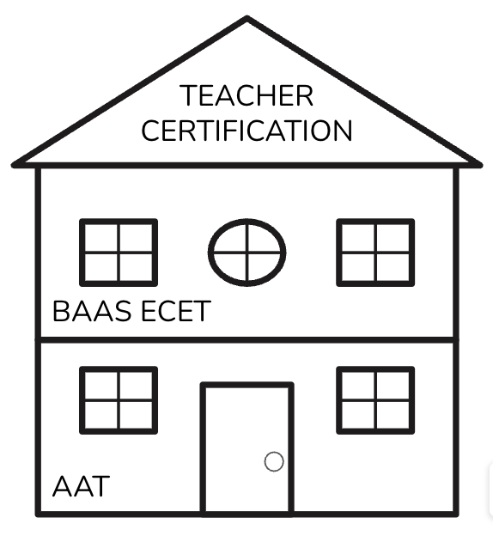

Bachelor of Applied Arts & Sciences in Early Childhood Education & Teaching
The Bachelor of Applied Arts & Sciences in Early Childhood Education & Teaching (BAAS ECET) is a 60-hour upper-division degree designed to stack directly onto a completed Associate of Arts in Teaching (AAT) or equivalent transfer credit. Students enter the program having already fulfilled general education and prerequisite coursework (e.g., foundational classes in child development, special populations, science, and mathematics) prior to admission. The BAAS ECET focuses exclusively on advanced content and experiential learning aligned to early childhood through sixth grade (EC–6) teaching competencies.
Eligibility. The minimum eligibility requirements for admission to the BAAS ECET degree program are designed to ensure that Candidates possess the appropriate academic preparation and eligibility, including:
- GPA Requirement: Minimum 2.75 cumulative GPA on a 4.0 scale
- College Credit Hours: A minimum of 51 earned semester credit hours by the start of the program (or concurrent AAT completion)
- TSI Compliance: Demonstrated TSI compliance in reading, writing, and mathematics
- English Language Proficiency: English proficiency is required under the TAC and may be demonstrated through TSI compliance or, when applicable, a scale score falling in the High Intermediate Level in each section of the Test of English as a Foreign Language Internet-Based Test (TOEFL-iBT).
- Prerequisite Coursework: Completion (or in-progress enrollment) in BIOL 1408 Biology for Non-Science Majors I, GEOL 1403 Geology, EDUC 1301 Introduction to Teaching, EDUC 2301 Introduction to Special Populations, MATH 1350 Mathematics for Teachers I, MATH 1351 Mathematics for Teachers II, PHYS 1415 Physical Science
Coursework. Coursework in the BAAS ECET is delivered in a blocked, cohort-based format, with Candidates completing five integrated courses per semester alongside the same group of peers. This structure allows faculty to coordinate assignments, reinforce interdisciplinary connections, and provide cohesive, scaffolded support across content areas. All certification-embedded coursework is delivered in a 16-week, face-to-face format, consistent with educator preparation. Each certification-embedded course (indicated with an *asterisk) meets one time per week for 75 minutes in a synchronous classroom setting. Across the 15 upper-division certification-embedded courses completed over four academic blocks, this delivery model provides a total of 300 clock hours of face-to-face instructional time toward certification. These instructional hours are separate from required Field-Based Experiences, the two-semester clinical teaching sequence, and state-mandated trainings. The WC EPP does not include prohibited instructional content in any coursework, field experience, or training. Candidates acknowledge this compliance requirement as part of the admissions process.

Figure 2
Recommended Course Sequence
Semester 1 Block A (15 hours)
Course # | Title | Hours
*EDEC 3301 | Supervised Experiences in Early Childhood | 3
EDEL 3318 | Elementary Geometry | 3
*EDLL 3301 | Language and Literacy Acquisition | 3
EDTP 3301 | Foundations of Inclusion and Differentiation for Special Populations | 3
EDEC 3305 | Prenatal and Infant Development | 3
Semester 2 Block B (15 hours)
Course # | Title | Hours
*EDEC 3302 | Supervised Experiences in Upper Elementary | 3
EDEC 3307 | Child Development | 3
*EDEL 4301 | Methods of Teaching Elementary Social Studies | 3
*EDLL 3305 | Foundations in Reading Instruction | 3
*EDTP 3303 | Behavior Management in Special Populations | 3
Semester 3 Block C (15 hours)
Course # | Title | Hours
EDEC 3303 | Child & Adolescent Guidance | 3
*EDEL 4302 | Methods of Teaching Elementary Science | 3
*EDEL 4303 | Methods of Teaching Elementary Mathematics | 3
*EDEL 4311 | Student Teaching/Clinical Apprenticeship I | 3
*EDTP 3305 | Designing Assessments for General & Special Populations | 3
Semester 4 Block D (15 hours)
Course # | Title | Hours
*EDEC 3309 | Development in a Cross-Cultural Context | 3
*EDEL 4312 | Student Teaching/Clinical Apprenticeship II | 3
*EDIT 3310 | Instructional Technology | 3
*EDTP 4310 | Content Area Literacy | 3
*EDTP 4315 | Advanced Methods for Teaching Special Populations | 3

Summer Course Offerings. To support flexible scheduling and timely degree completion, several core courses are offered each summer. These include EDEC 3303 (Child and Adolescent Guidance), EDTP 3303 (Behavior Management in Special Populations), EDEC 3305 (Prenatal and Infant Development), and EDIT 3310 (Instructional Technology). Students may enroll in these courses during the summer to reduce semester course loads or complete the program on an accelerated timeline.
Academic Standing. Academic standing refers to a student’s ability to maintain satisfactory academic progress and meet program expectations related to grades, participation, and degree completion. Students must remain in good academic standing in order to continue progressing through the degree plan, enroll in field-based coursework, and (if applicable) participate in clinical teaching and certification activities. Academic standing is closely monitored and reviewed each semester.
To remain in good academic standing in the BAAS ECET program, students must meet the following minimum requirements:
- Maintain a cumulative GPA of 2.75 or higher
- Earn a grade of C or better in all BAAS ECET upper-division courses
- Attend at least 80% of all scheduled face-to-face and synchronous class sessions each semester
Graduation Requirements. To earn the BAAS ECET degree, students must meet all credit, GPA, course grade, and administrative requirements, including:
- Complete a total of 120 semester credit hours, which includes:
  - 60 hours of lower-division coursework
  - 60 hours of upper-division coursework
- Earn a cumulative GPA of 2.75 or higher
- Earn a grade of C or better in all BAAS ECET upper-division courses
- Texas Core Curriculum complete (42 credit hours of state-mandated core courses)
- Fulfill all financial and administrative obligations to Weatherford College
- Submit an official graduation application through the Weatherford College website by the Registrar’s posted deadline (wc.edu/current-students/graduation/graduation-information.php
Teacher Certification
In order to become certified Texas teachers, Candidates must successfully complete a series of instructional, clinical, assessment, and legal requirements as defined in the Texas Administrative Code. The BAAS ECET/WC EPP is structured as a dual-enrollment model in which students simultaneously earn a bachelor’s degree and complete all necessary components for Texas educator certification. Certification readiness is embedded throughout coursework, field-based experiences, and training modules, and is tracked through structured benchmarks and documentation in each Candidate’s Watermark portfolio.
Eligibility. To be eligible for standard teacher certification in Texas, Candidates must meet baseline legal and procedural qualifications grounded in the Texas Administrative Code (TAC) and enforced by the Texas Education Agency (TEA).
Eligibility criteria include:
- Bachelor’s Degree Enrollment: Candidates must be enrolled in the Bachelor of Applied Arts and Sciences in Early Childhood Education and Teaching (BAAS ECET), a state-approved baccalaureate degree program for EC–6 certification.
- Official Transcript(s): Unofficial transcripts may be submitted with the program application for preliminary review, but do not satisfy this requirement. Official transcripts from all postsecondary institutions attended must be received and on file with Weatherford College before an applicant may be accepted into the BAAS ECET degree program or formally admitted to the WC EPP. Applicants whose official transcripts are not issued in English must submit a course-by-course credential evaluation from a TEA-approved evaluation service.
- School-Based Experience Eligibility: Candidates must meet all eligibility, identification, criminal-history, fingerprinting, and other requirements established by Weatherford College and participating school districts for participation in field-based experiences and clinical teaching. Candidates must possess acceptable government-issued identification and remain eligible to participate in field-based experiences and clinical teaching.
- English Language Proficiency (if applicable): English proficiency is required under the TAC and may be demonstrated through TSI compliance or, when applicable, a scale score falling in the High Intermediate Level in each section of the Test of English as a Foreign Language Internet-Based Test (TOEFL-iBT).
- Criminal Background Check: Candidates must satisfy all criminal history and fingerprinting requirements applicable to educator preparation, clinical teaching, and Texas educator certification. Candidates are responsible for completing required fingerprinting and background-check procedures through the process designated by the Texas Education Agency (TEA) and for maintaining eligibility to participate in field-based experiences and clinical teaching. Criminal history information may affect a Candidate’s eligibility for clinical teaching, program completion, or educator certification.
- Preliminary Criminal History Evaluation: Individuals who have reason to believe that their criminal history may affect eligibility for Texas educator certification are encouraged to request a Preliminary Criminal History Evaluation (PCHE) from TEA. The PCHE allows an individual to obtain an evaluation of potential certification eligibility before completing an educator preparation program. A PCHE does not replace any required fingerprinting, criminal history review, or certification process. Visit the website below to learn more –
https://tea.texas.gov/texas-educators/investigations/preliminary-criminal-history-evaluation-faqs

Requirements. Once a Candidate is determined eligible, the following academic, clinical, and assessment-based requirements must be completed to qualify for standard certification in Texas.
- TEA ID: All applicants must create a TEA Login (TEAL) account and obtain a unique TEA ID number prior to admission into the Weatherford College Educator Preparation Program (WC EPP).
- Certification Eligibility & Criminal History: Criminal history may affect eligibility for educator certification and are informed of the option to request a Preliminary Criminal History Evaluation (PCHE) from TEA. Candidates must satisfy applicable fingerprinting, criminal-history, district/campus access, and clinical teaching eligibility requirements before clinical teaching and must remain eligible to be recommended for Texas teacher certification.
- Educator Preparation Coursework: Candidates complete a minimum of 300 clock-hours of educator preparation coursework and training aligned with applicable educator standards and certification requirements. Before beginning clinical teaching, Candidates complete at least 150 clock-hours of required educator preparation coursework and training, including preservice practice and performance-based opportunities to demonstrate required pedagogical knowledge and skills. Completion of pre-clinical coursework and training is verified before the Candidate is approved to enter Clinical Teaching I. The WC EPP complies with applicable current state requirements and restrictions governing educator-preparation curriculum. Program syllabi and instructional modules are reviewed for ongoing compliance.
- Field-Based Experiences (FBE): Before clinical teaching, Candidates must complete 50+ hours of field-based experiences in authentic school settings with the support of the FBE Coordinating Teacher; WC requires a minimum of 80% of those hours actively engaged in instructional or educational activities.
- Clinical Teaching: Candidates must complete 490+ hours in one 28-week, two-semester clinical teaching assignment (245+ hours per semester). These hours must be guided by a qualified Cooperating Teacher and evaluated by a trained Field Supervisor.
- Start-of-School-Year Experience. Candidates must experience the professional responsibilities associated with the start of the school year. When this experience cannot be completed during clinical teaching, it will be incorporated into field-based experiences.
- Certification Exams: Candidates must pass all required Texas Examinations of Educator Standards (TExES), including Core Subjects EC–6 (391), Science of Teaching Reading (STR, 293), and Pedagogy and Professional Responsibilities EC–12 (PPR, 160). Before granting clearance for Candidates to sit for a certification exam, WC EPP requires a score of 85%+ on a related representative assessment.
- Application for Certification and TEA Fees: As the Chief Operating Officer, the BAAS ECET/WC EPP Chief Operating Officer submits the formal recommendation for certification verifying all requirements have been met. Candidates must submit the official online application for certification and pay all applicable TEA and testing fees through the TEAL system in order to be recommended for certification.
Degree-Only Option
While the majority of BAAS ECET students pursue both the bachelor’s degree and initial teacher certification through the integrated WC EPP, the program also offers a degree-only completion option for students who choose not to pursue certification. Students pursuing the degree-only option (without educator certification) must complete a modified degree plan, developed in collaboration with the Chief Operating Officer at the time of voluntary exit from the WC EPP. This plan includes alternative coursework in place of clinical teaching and is intended to support students in completing their bachelor’s degree while preparing for future roles in educational services, child and family development, or related fields. Degree-only students are not eligible to participate in WC EPP field-based experiences or clinical teaching and are not eligible for certification recommendation.

4. Milestones & Progress Monitoring
The BAAS ECET/WC EPP maintains a comprehensive, structured system for monitoring each Candidate’s academic, professional, and clinical growth. This system is grounded in a developmental model that recognizes teacher preparation as a progression of learning experiences and skill-building opportunities. The program benchmarks are designed not only to ensure compliance with state regulations, but also to promote excellence, transparency, and intentional preparation for the realities of classroom teaching.
4.1 Milestone-Based Progression
Candidate progress through the BAAS ECET/WC EPP is structured around a series of developmental milestones that ensure readiness for classroom teaching and certification. These milestones are intentionally sequenced across four instructional blocks (semesters), with clearly defined expectations in the areas of coursework, field experience, professional dispositions, legal compliance, and assessment preparation. The program uses these milestones to monitor and verify that each Candidate is making adequate academic progress, fulfilling state and program requirements, and demonstrating the knowledge, skills, and ethical behaviors expected of a Texas educator. Each milestone serves as a performance gate, meaning that Candidates must meet all required indicators for the semester before advancing to the next stage of the program. At each stage, Candidates receive targeted support through ongoing advising and formal semester audits to help them remain on track. Candidates who do not meet one or more milestone requirements may be placed on a growth plan, referred for additional support, or delayed in their progression until all standards are met.
Table 4 outlines the key milestones and progression gates expected of all Candidates as they progress through their degree and credentialing work.

Table 4
BAAS ECET/WC EPP Candidate Milestones & Progression Gates
Stage | Major Requirements | Field-Based/Clinical Experience | Progression Gate(s)
Pre-Program | Formal Admission: Admission requirements satisfied; Formal Admission Offer Letter issued; Intent to Enroll Agreement returned; formal admission effective on the date stated in the offer letter.  Post-Admission Onboarding: Initial advising; individualized two-year plan; required orientation; Candidate acknowledgements and agreements. | — | Formal admission effective; post-admission onboarding requirements completed
Block A – Semester 1 | EDEC 3301, EDEC 3305, EDEL 3318, EDLL 3301, EDTP 3301; TEA ID; government-issued photo ID; criminal background check; fingerprinting | Early Childhood FBE: 25+ FBE hours in kindergarten, first-, or second-grade authentic school settings; experiences must occur across multiple classroom and school-based contexts and may not be completed entirely within a single classroom; the FBE Coordinating Teacher facilitates access to appropriate experiences within the teacher’s classroom and across other authentic school settings; Early Childhood FBE Timesheet, Teaching Demonstration, Structured Observation Logs, Final Reflections. | Quarterly Degree & Certification Audit; 2.75+ GPA; C or higher in all courses; satisfactory FBE tasks and dispositions; approval to progress to Block B
Block B – Semester 2 | EDEC 3302, EDEC 3307, EDEL 4301, EDLL 3305, EDTP 3303; criminal background check; Dyslexia training; Texas Behavior Support Initiative | Upper Elementary FBE: 25+ FBE hours in third-, fourth-, fifth-, or sixth-grade authentic school settings; experiences must occur across multiple classroom and school-based contexts and may not be completed entirely within a single classroom; the FBE Coordinating Teacher facilitates access to appropriate experiences within the teacher’s classroom and across other authentic school settings; Upper Elementary FBE Timesheet, Teaching Demonstration, Structured Observation Logs, Final Reflections. | TExES 293 STR after ≥85% on representative exam; Quarterly Degree & Certification Audit; 2.75+ GPA; C or higher; satisfactory FBE tasks and dispositions; approval to enter Clinical Teaching I
Block C – Semester 3 | EDEL 4311, EDEC 3303, EDEL 4302, EDEL 4303, EDTP 3305; criminal background check; Mental Health Awareness; Substance Abuse Prevention; Suicide Prevention | Clinical Teaching I – First Half: First 245+ hours of the 490+ hour EC–6 clinical teaching assignment; two formal observations by the WC EPP Field Supervisor; first formal observation within the first third of the clinical teaching assignment; all formal observations conducted in person; three informal observations of at least 15 minutes each, with the first conducted in person within the first six weeks; documented collaboration among the Field Supervisor, Cooperating Teacher, and Candidate; Timesheets; Informal Observations; Formal Observations; Midpoint Evaluation. | TExES 160 PPR after ≥85% on representative exam; Quarterly Degree & Certification Audit; 2.75+ GPA; C or higher; satisfactory clinical teaching performance and dispositions; completion of 245+ hours; approval to enter Clinical Teaching II
Block D – Semester 4 | EDEL 4312, EDEC 3309, EDIT 3310, EDTP 4310, EDTP 4315; criminal background check; Proactive Instructional Planning and Evidence-Based Inclusive Practices | Clinical Teaching II – Second Half: Second 245+ hours of the same 490+ hour EC–6 clinical teaching assignment; two formal observations by the WC EPP Field Supervisor; all formal observations conducted in person; three informal observations of at least 15 minutes each, with the first conducted in person within the first six weeks; documented collaboration among the Field Supervisor, Cooperating Teacher, and Candidate; Timesheets; Informal Observations; Formal Observations; Final Evaluation. | TExES 391 Core Subjects EC–6 after ≥85% on representative exam; Quarterly Degree & Certification Audit; 2.75+ GPA; C or higher; satisfactory clinical teaching performance and dispositions; completion of 245+ hours; all coursework completed; testing milestones met or test-eligible; verification of all EPP requirements and recommendation for certification
Program Completion & Certification | Complete certification application requirements following program completion and EPP recommendation | — | EPP recommendation for the applicable Texas educator certificate
FBE Variety Requirement: Candidates must experience multiple classrooms and school-based contexts during each 25+ hour field-based experience; each FBE must include experiences beyond a single classroom.

4.2 Advising
Advising is a central component of the BAAS ECET/WC EPP and serves as the primary method for supporting each Candidate’s academic, professional, and certification progress. Through regular, individualized advising meetings, the BAAS ECET Program Director provides targeted guidance, monitors degree and certification benchmarks, and helps Candidates plan for success. Advising occurs at multiple stages from initial entry into the program to the final semester of clinical teaching. Support is designed to be proactive, personalized, and fully aligned with the program’s benchmarks and state accountability standards.
Initial Advising
All Candidates admitted to the BAAS ECET/WC EPP begin their journey with a required one-on-one advising session during their first semester (Block A). Prior to this meeting, the Program Director conducts a full degree review as part of the admission screening process. During the advising session, the Director uses the AAT-BAAS ECET Pathway Academic Advising Guide (Figure 3) to conduct a degree audit and document course registration. From there, the Candidate and Director create a personalized Two-Year Plan (Figure 4) outlining the ideal course sequence, anticipated field-based experiences and clinical teaching assignment, and estimated timelines for certification exam preparation. This plan serves as a living document, updated each semester during scheduled progress reviews. These structured advising checkpoints ensure that each Candidate maintains a clear, semester-by-semester understanding of academic expectations, certification benchmarks, and field-based experience requirements from admission to program completion.
Figure 3
AAT-BAAS ECET Advising Guide
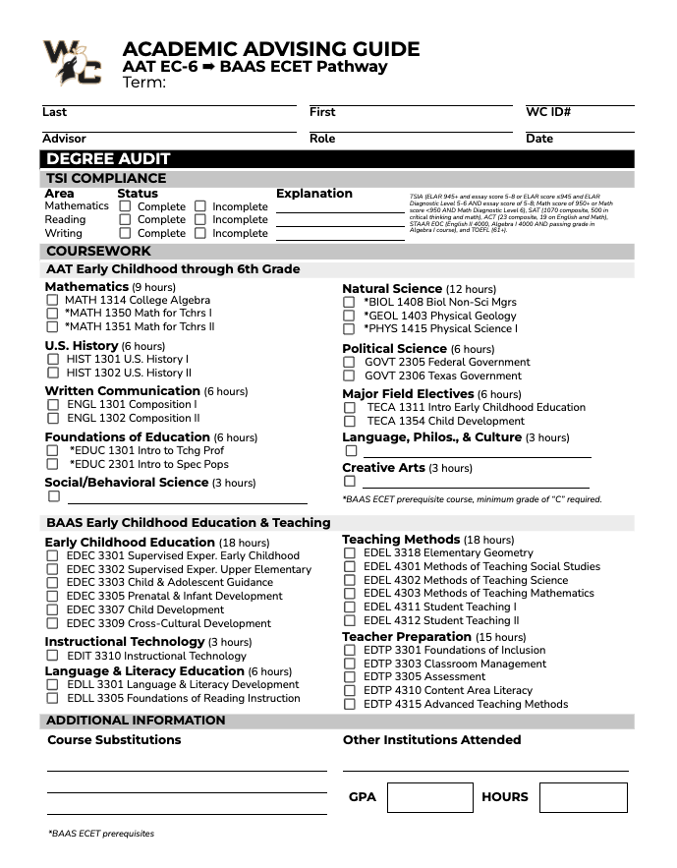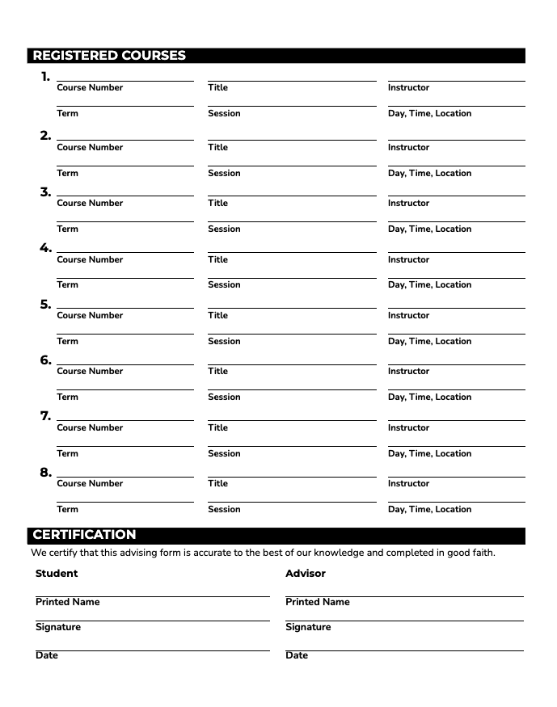

Figure 4
Two-Year Plan
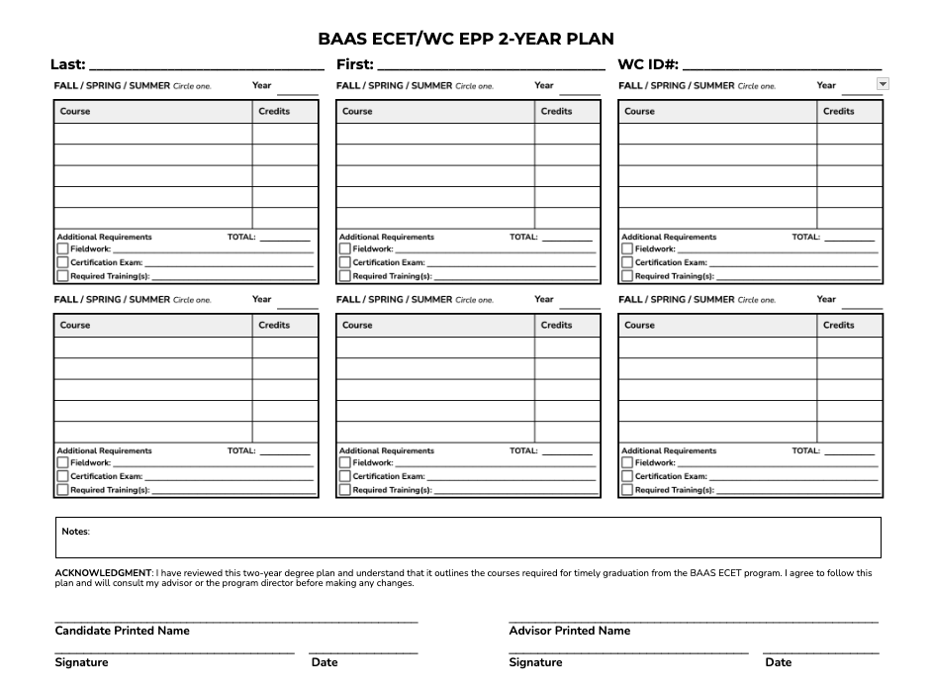
Ongoing Advising
In order to receive continuous support throughout enrollment, every Candidate in the BAAS ECET/WC EPP meets with the Program Director for an advising appointment each semester. During these sessions, the Program Director shares the results of the Candidate’s degree and certification audit, reviews any active growth plans or probationary status, and provides guidance on upcoming program requirements. Registration for the following semester is completed during this advising meeting to ensure that all Candidates stay on track.
Quarterly Degree & Certification Audit. Each semester, the BAAS ECET/WC EPP Program Chief Operating Officer conducts a formal Quarterly Degree and Certification Audit for every enrolled Candidate using a cumulative audit form maintained in the Candidate’s official file. This process is designed to ensure ongoing alignment with the Texas Administrative Code (TAC) which requires educator preparation programs to implement structured benchmarks for tracking Candidate progress. Additionally, this audit process supports transparency, ensures timely interventions, and provides a clear record of each Candidate’s trajectory toward program completion and certification. As illustrated in Figure 5, the form is updated each semester by the Program Chief Operating Officer and retained in the Candidate’s cumulative folder. While it is used as an internal monitoring tool, Candidates may request a copy in writing at any time. The form also includes a recommendation section documenting whether the Candidate is making satisfactory progress, requires a growth plan, or has been placed on probation or referred for dismissal.

Figure 5
Quarterly Degree & Certification Audit
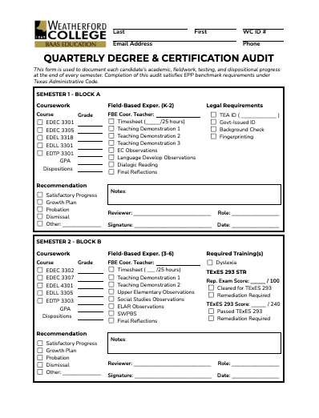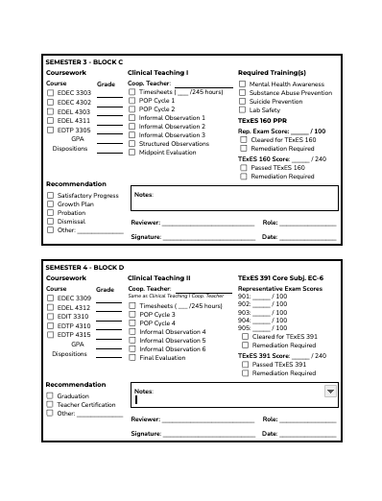
4.3 Progress Monitoring Records Retention
The BAAS ECET/WC EPP maintains secure, confidential records for all enrolled Candidates in accordance with Weatherford College policy, the TAC and the Family Educational Rights and Privacy Act (FERPA). Candidate records include admission documents, degree and certification audits, field-based experience and clinical teaching documentation, growth plans, evaluations, disposition records, as well as certification testing approvals and exam results. All records are retained for a minimum of five years following a Candidate’s completion, dismissal, or withdrawal from the program. These records are stored in secure electronic systems with access limited to authorized program personnel. In accordance with FERPA, Candidates have the right to inspect and review their education records upon request, request an amendment to records they believe are inaccurate, as well as provide written consent before the program discloses personally identifiable information - except as permitted by FERPA or other applicable law. Candidates wishing to access or request a copy of their records must submit a written request. Requests will be fulfilled within a reasonable timeframe, typically within 10 business days. For more information about FERPA, please visit: https://studentprivacy.ed.gov/ferpa

5. | Professional Conduct

The BAAS ECET/WC EPP is committed to preparing ethical, responsible, and resilient educators who meet the highest standards of the teaching profession. In accordance with Texas Administrative Code, Candidates are expected to demonstrate professional conduct, uphold the Texas Educators’ Code of Ethics, and comply with all programmatic and legal responsibilities throughout their enrollment. This section outlines professional standards, expected professional dispositions, procedures for addressing conduct and academic concerns, exit policy, as well as steps to resolve conflict.
5.1 Standards
Admission to BAAS ECET/WC EPP represents a formal commitment to the responsibilities of the teaching profession. As future educators, all teacher Candidates are held to high standards of professionalism, academic integrity, and ethical conduct throughout their time in the program and into their careers. The following expectations outline the behaviors, attitudes, and responsibilities required of all Candidates to remain in good standing and successfully complete the program. By signing the Professional Dispositions Acknowledgement, Handbook Acknowledgement, and Commitments Forms, Candidates agree to uphold the Weatherford College Student Handbook, Texas Educators’ Code of Ethics, WC EPP Professional Dispositions, aligned with the Texas Teacher Standards and InTASC standards.
Weatherford College Student Handbook
BAAS ECET students/Candidates must adhere to the policies outlined in the Weatherford College Student Handbook as it relates to non-success in academic performance, behavioral misconduct, and academic integrity.
Texas Educators’ Code of Ethics
Candidates in the BAAS ECET/WC EPP are held to the highest standards of professional conduct as outlined in the Texas Educators’ Code of Ethics. Adherence to these ethical standards is not only a requirement for certification in the state of Texas but a foundational expectation throughout the program. Professional conduct is evaluated continuously through coursework and school-based practice from faculty, FBE coordinating teachers, Cooperating Teachers, and Field Supervisors, as applicable. The BAAS ECET/WC EPP evaluates professionalism through both observable behaviors and professional dispositions. Candidates are expected to model ethical behavior, sound judgment, and integrity in all settings. Key components include:
- Maintaining respectful and appropriate communication with peers, instructors, school-based educators, students, and families
- Demonstrating reliability, punctuality, and accountability in all course and fieldwork commitments
- Dressing professionally and adhering to school/district appearance policies during field-based experiences and clinical teaching
- Responding constructively to feedback and engaging in reflective practice
- Protecting student confidentiality in accordance with FERPA and district policies
- Avoiding all behavior, online or in person, that may compromise professional credibility or ethical standing
Professional Dispositions
Professional dispositions encompass a range of behaviors and attitudes that are integral to the success and credibility of a teacher. Aligned with the Texas Teacher Standards (TTS) and informed by the Interstate New Teacher Assessment and Support Consortium (InTASC) standards, these dispositions are not just desirable traits, but essential components of effective teaching and professional conduct in the field of education. Candidates will be evaluated by instructors and designated school-based educators, including FBE Coordinating Teachers and Cooperating Teachers, as applicable. All BAAS ECET/WC EPP Candidates must develop the following dispositions to successfully complete the program, including:
- Prepared & Punctual: The teacher Candidate is prepared and punctual [TTS: 5(A)(ii); InTASC: 9O].
- Professional Relationships: The teacher Candidate develops and maintains appropriate professional relationships with students, peers, colleagues, and school personnel TTS: 4, 5(A)(i), 5(B)(iii)–(vi), 5(C)(i); [InTASC: 3O, 7O, 9B, 9C, 10G, 10I, 10R]
- Professional Communication: The teacher Candidate communicates clearly, appropriately, and professionally within the learning environment [TTS: 2(A)(i), 5(C); InTASC: 3F, 8M, 8Q].
- Adaptations & Accommodations: The teacher Candidate makes appropriate adaptations and accommodations to address individual learning needs [TTS: 1(D)(i)–(iii), 1(E)(ii)–(iv), 2(A)(v)–(viii), 3(B)(v); InTASC: 6P, 6U, 7B, 9G].
- Professional Flexibility: The teacher Candidate demonstrates professional flexibility by adjusting plans, practices, and responses when circumstances, feedback, or student needs require change [TTS: 1(D)(iii), 2(A)(v), 2(C)(iii), (vi), 5(B)(i)–(iv); InTASC: 1A, 1G, 5S, 7F, 7L, 7Q, 8B, 8P, 9G].
- Initiative & Responsibility: The teacher Candidate demonstrates initiative and responsibility in planning, completing tasks, maintaining records, and meeting deadlines [TTS: 1, 2, 5(A)(ii), 5(B)(iii); InTASC: 6R, 7B, 7D, 7E, 7F, 7L, 7P, 10R].
- Response to Feedback: The teacher Candidate accepts, reflects upon, and acts on constructive feedback [TTS: 5(B)(i)–(iii); InTASC: 10T].
- Professional Growth: The teacher Candidate actively pursues professional growth opportunities [TTS: 5(B)(iii)–(v); InTASC: 9A, 9B, 9K].
- Teaching Expertise: The teacher Candidate continually develops and refines their knowledge and expertise in teaching [TTS: 3(A)(v), 5(B)(i)–(iv); InTASC: 4(O), 9(A), 9(B), 9(D), 9(K), 9(N)].
- High Expectations: The teacher Candidate maintains high expectations for student learning and professional performance [TTS: 2(B)(i), 4(B)(i), 5(B)(iii); InTASC: 10O].
- Laws, Policies, & Professional Responsibilities: The teacher Candidate complies with applicable educational laws, policies, procedures, and professional responsibilities [TTS: 5(A)(i)–(ii); InTASC: 9J, 9O].
- Ethical & Scholastic Integrity: The teacher Candidate demonstrates ethical conduct and scholastic integrity [TTS: 5(A)(i)–(ii); InTASC: 5K, 6V, 9F, 9O].
Legislative Compliance
In accordance with HB 2 (89th Legislature), all Candidates and faculty must comply with requirements for synchronous training, preservice practice, and content prohibitions outlined in Texas Education Code. Candidates found to be in violation of these provisions may be subject to corrective action under the program’s accountability process, up to and including dismissal.
5.2 Tiered Accountability Process
To uphold the standards of the teaching profession and protect program integrity, the BAAS ECET/WC EPP implements a structured, tiered accountability process for addressing concerns related to academic performance, professional conduct, fieldwork readiness, and ethical responsibility. This system is developmental, not punitive. It is designed to support Candidates in meeting expectations through targeted feedback, individualized plans, and documented interventions. The goal is to equip future educators with the dispositions, competencies, and decision-making capacity required to succeed in the classroom and earn standard teacher certification in Texas. As outlined in Figure 6, the program applies a three-tier model: Step 1: Growth Plan → Step 2: Probation → Step 3: Dismissal. Each tier represents a progressive level of support and documentation. Candidates may begin at any tier depending on the nature and severity of the concern.
Figure 6
Tiered Accountability Process
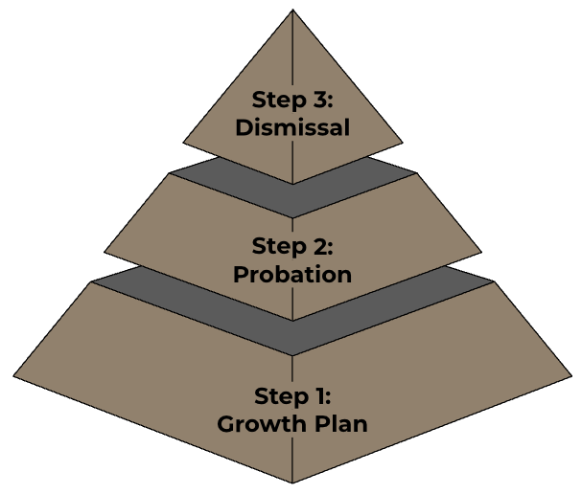
Step 1. Growth Plan
A Candidate may be placed on a Growth Plan when concerns arise that do not yet warrant immediate probation or dismissal but indicate a need for targeted support. These concerns may reflect early patterns in academic, professional, or instructional performance, and must be addressed to ensure the Candidate is progressing toward certification readiness.
Step 2. Probation
A Candidate may be placed on Program Probation when (1) they fail to fulfill the expectations outlined in a Growth Plan, or (2) they engage in behavior or demonstrate performance that presents a significant concern and requires immediate formal intervention. These concerns may include (but are not limited to) ethical violations, repeated unprofessional conduct, or failure to maintain academic standing. While on probation, the Candidate remains enrolled in the BAAS ECET/WC EPP but is no longer in good standing. Additional restrictions may be imposed to ensure that the Candidate receives appropriate support and oversight.
Step 3. Dismissal
If a Candidate fails to meet the expectations outlined in a probationary plan or has been inactive for two calendar years, they are dismissed from the BAAS ECET/WC EPP. Dismissal marks the final tier in the accountability process and reflects the Candidate’s inability or unwillingness to demonstrate the growth required to remain in good standing. Dismissal decisions are made by the BAAS ECET/WC EPP Chief Operating Officer in consultation with the Dean of Academics and Vice President of Academics. Dismissed Candidates will receive a formal dismissal notice documenting the rationale and outcome. They will be withdrawn from program coursework, field experiences, and certification-related activities and will receive written documentation outlining the decision.
5.3 Exit Policy
Voluntary withdrawals and dismissals constitute formal exits from the BAAS ECET and/or WC EPP.
Voluntary Withdrawal
Candidates admitted to the BAAS ECET/WC Educator Preparation Program may elect to voluntarily exit either the educator certification component or the entire program, depending on their academic goals, personal circumstances, or evolving career plans. Because the WC EPP is embedded within the BAAS ECET degree, participation in the certification pathway is contingent upon active enrollment in the BAAS ECET. Candidates may not remain in the WC EPP if they are no longer pursuing the degree. To initiate a voluntary exit, candidates must complete and submit the official Request to Withdraw Form to the Program Director. The form allows candidates to indicate whether they are exiting the certification pathway only (while continuing in the BAAS ECET degree) or withdrawing from both programs. Upon receipt of the form, the Program Director will review the candidate’s file, confirm their status at the time of exit (Good Standing, Growth Plan, or Probation), and document the effective date of withdrawal. Students exiting the certification pathway will receive a modified degree plan to ensure they can complete the BAAS ECET without clinical teaching or field placements. Alternate coursework may be assigned based on individual graduation needs and long-term goals.
Dismissal
Candidates may also involuntarily exit the program through dismissal. This may occur when a Candidate fails to meet academic performance standards, professional disposition expectations, ethical or legal requirements; certification eligibility requirements, including but not limited to violations of the Texas Educators’ Code of Ethics, failure to maintain required GPA; unsuccessful field-based experiences or clinical teaching; loss of eligibility for Texas educator certification; or inactivity for two consecutive calendar years. Dismissal decisions are based on documented evidence and are communicated to the Candidate in writing, including the reason for dismissal and information regarding appeal or grievance procedures, when applicable.
5.4 Complaints & Grievances
The BAAS ECET/WC EPP values open communication, professional collaboration, and ethical decision-making as essential components of effective teacher preparation. While the program strives to foster a positive, supportive learning environment, it also acknowledges that concerns or conflicts may arise. When they do, Candidates have the right to seek resolution through the clear, respectful, and fair process outlined in Figure 7.

Figure 7
Complaints & Grievances Procedure
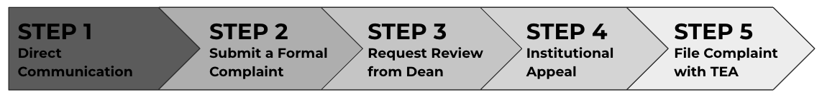

Step 1. Address the Concern Directly
Most issues can be resolved quickly and informally through respectful conversation, clarification, or feedback. When appropriate and safe to do so, attempt an informal resolution. Communicate directly with the person or party involved (e.g., faculty member, Field Supervisor, or staff member) and send a follow-up email to document the conversation.
Step 2. Submit a Complaint Form
If the concern is not resolved through direct communication, escalate the issue by submitting a formal complaint to the BAAS ECET/WC EPP Chief Operating Officer. Use the official Complaint Form, which is available through the program website or by request. Upon receiving the completed Complaint Form, the Program Chief Operating Officer will: acknowledge receipt of the complaint via email within three (3) business days; conduct a thorough review; and respond in writing to the Candidate with a summary of findings and a proposed resolution or action plan within ten (10) business days.
Step 3. Request a Review by the Dean of Academics
If the resolution provided by the Chief Operating Officer is unsatisfactory, formally request a review by the Dean of Academics. To initiate this step, the Candidate must submit a written request for review within ten (10) business days of receiving the Chief Operating Officer’s response to the Complaint Form. The Dean will evaluate the full grievance record (i.e., complaint history, supporting documents, and prior communication) to determine whether further mediation, academic review, or corrective action is warranted. The Candidate may be contacted to clarify information or participate in a follow-up conversation. The Dean will provide a written decision or resolution plan, typically within ten (10) business days of receiving the request.
Step 4. Institutional Appeal
If all internal program and departmental steps have been exhausted and the issue remains unresolved, submit a formal grievance to the Executive Vice President of Academics and Chief Academic Officer by filling out the Student Complaint or Grievance Form. The decision of the Executive Vice President constitutes the final institutional response.
Step 5. File a Complaint with the Texas Education Agency
If it appears that WC violated state law and/or failed to follow proper procedures, and all institutional grievance steps have been exhausted, file a written complaint with the Texas Education Agency (TEA). TEA will only review complaints that fall under its regulatory authority and jurisdiction. To learn more, please visit: Complaints Against Educator Preparation Programs
5.5 Professional Conduct Records Retention
All documentation related to professional conduct, disciplinary actions, grievance proceedings, and appeals within the BAAS ECET/WC EPP is retained for a minimum of five years from the date of the Candidate’s completion, withdrawal, or formal separation from the program. These records serve to document due process, uphold legal and ethical standards, and ensure alignment with institutional policy and Texas Administrative Code. Candidates may request access to their records by submitting a formal request in writing to the Program Chief Operating Officer, in accordance with institutional FERPA guidelines.

6. | Financial Information

The Bachelor of Applied Arts and Sciences in Early Childhood Education and Teaching/Weatherford College Educator Preparation Program (BAAS ECET/WC EPP) is intentionally designed to offer an affordable, high-quality pathway for aspiring educators to earn both a bachelor’s degree and Texas teacher certification. Recognizing that many students in our program are working adults, first-generation college students, or career changers, we are committed to supporting financial transparency from the outset.
6.1 Tuition & Fees
Understanding the full financial commitment of the BAAS ECET/WC EPP is essential for prospective teacher Candidates. This section outlines estimated tuition and institutional fees based on full-time enrollment in upper-division coursework. Cost projections are provided per semester and across the full four-semester program, with variations based on residency status. These estimates are designed to support transparent financial planning and ensure that Candidates are fully informed of the investment required to complete their bachelor’s degree and educator preparation program.
Cost Per Semester
Table 5 provides a breakdown of estimated tuition and fees for BAAS ECET/WC EPP Candidates enrolled in 15 credit hours per semester during the 2024–2025 academic year. Rates vary by residency status and include instructional costs as well as institutional fees such as enrichment, technology, and online course delivery. All students, except those enrolled through the Wise County campus or in dual credit programs, are also assessed a flat-rate $250 Student Center Fee. The total per-semester cost ranges from approximately $2,875 for in-district students to $5,660 for out-of-state students.

Table 5
Estimated Tuition & Fees (Per Semester, 15 Credit Hours)
Fee Category | In-District | Wise County | Out-of-District | Out-of-State
Base Tuition | $1,875 | $2,430 | $3,300 | $4,660
Enrichment Fee | $375 | $375 | $375 | $375
Technology Fee | $225 | $225 | $225 | $225
Online Course Fee | $150 | $150 | $150 | $150
Student Center Fee | $250 | Exempt | $250 | $250
Total Tuition & Fees | $2,875 | $3,180 | $4,300 | $5,660
Note. Adapted from Tuition and Fees Schedule (2024–2025), Weatherford College.

Four-Semester Total
Table 6 outlines the projected total cost of tuition and fees over four semesters for BAAS ECET/WC EPP Candidates enrolled full-time in 15 credit hours per term. These totals represent the cumulative cost of 60 upper-division credit hours, inclusive of base tuition and all standard institutional fees such as technology, enrichment, online delivery, and the student center fee where applicable. Depending on residency status, students can expect to pay approximately $11,500 to $22,640 over the course of the program. In-district and Wise County residents benefit from significantly reduced rates due to local tax contributions that offset tuition, while out-of-district and out-of-state students incur higher tuition costs. These estimates reflect a standard two-year completion timeline and do not include optional summer coursework or additional fees for retakes or program extensions.

Table 6
Estimated Four-Semester Total (Per Semester, 15 Credit Hours)
Residency Type | Per Semester | Estimated 4-Semester Total
In-District | $2,875 | $11,500
Out-of-District (Wise County) | $3,180 | $12,720
Out-of-District (Non-Wise) | $4,300 | $17,200
Out-of-State | $5,660 | $22,640
Note. Estimates are based on full-time enrollment in 15 credit hours per semester across four consecutive semesters. Totals include tuition and standard institutional fees and are subject to change based on college policy or student residency classification.
Adapted from Tuition and Fees Schedule (2024–2025), Weatherford College.

6.2 Certification Costs
Table 7 provides an overview of the estimated out-of-pocket costs associated with the teacher certification process in Texas. These expenses are separate from tuition and institutional fees and cover critical components required for certification, including registration for state-mandated TExES exams, fingerprinting and background checks through the Texas Education Agency, and the standard certificate application fee. Actual costs may vary slightly depending on factors such as retesting, choice of preparation materials, or changes in state exam fees. These estimates are intended to provide a realistic financial planning benchmark for all students pursuing EC–6 standard certification in Texas and reflect the typical costs borne by teacher Candidates statewide.

Table 7
Certification-Related Expenses
Expense Category | Estimated Cost
TExES Core Subjects EC–6 (391) | $116
TexES STR (293) | $136
TexES PPR EC–12 (160) | $116
TEA Fingerprinting & Background Check | $49
TEA Standard Certificate Application | $78
Estimated Total | ~$495
Note. Certification-related expenses reflect average Candidate costs as of 2026 and may vary slightly based on individual testing needs, test retakes, or material costs.

6.3 Total Estimated Costs
As outlined in Table 8, completing the BAAS ECET program requires both institutional and state-level financial commitments. These totals include four semesters of tuition and standard institutional fees, as well as the required out-of-pocket expenses for certification. Depending on residency, Candidates can expect to invest between approximately $11,995 and $23,135 to complete the program and meet all certification requirements. These estimates reflect full-time enrollment in 15 credit hours per semester and include anticipated costs for TExES exams, fingerprinting, licensure application, and digital portfolio tools. While individual expenses may vary, this summary provides a realistic financial planning framework for future teacher Candidates. Students are encouraged to explore financial aid, scholarships, and employer-based tuition assistance to help manage overall costs.

Table 8
Estimated Total Program Cost (Tuition + Certification Expenses)
Residency Type | Tuition & Fees  (4 Semesters) | Certification-Related Costs | Estimated Total Program Cost
In-District | $11,500 | ~$495 | ~$11,995
Out-of-District (Wise Co.) | $12,720 | ~$495 | ~$13,215
Out-of-District (Non-Wise) | $17,200 | ~$495 | ~$17,695
Out-of-State | $22,640 | ~$495 | ~$23,135
Note. Tuition estimates are based on full-time enrollment over four semesters. Certification costs are based on current TEA and Pearson exam fees.

6.4 Financial Aid & Scholarships
A variety of financial aid options, institutional scholarships, and state and federal assistance programs are available to help reduce the overall cost of attendance. Students can learn more about financial aid, scholarships, and veterans’ benefits by visiting the Financial Aid, Scholarship Opportunities, or Veteran’s Aid sections of the Weatherford College website.
Financial Aid | (817)598-6295 | wc.edu/current-students/paying-for-college/financial-aid
Scholarship Opportunities | (817)598-6291 | wc.edu/alumni-and-giving/giving/scholarships
Veteran’s Benefits | (817) 598-6245 | wc.edu/current-students/paying-for-college/veterans-benefits
Workforce Solutions North Central Texas |(817) 598-2806 |wcworkforce@dfwjobs.com
References
Council of Chief State School Officers. (2013). InTASC model core teaching standards and learning progressions for teachers.
National Association for the Education of Young Children. (2020). Professional standards and competencies for early childhood educators
Texas Administrative Code. (n.d.). 19 Tex. Admin. Code §149.1001. Texas teacher standards.
Texas Administrative Code. (2026). Title 19, Part 7, Chapter 227–230.
Texas Education Agency. (2023). Teacher shortage areas, 2023–2024.
Texas Education Agency. (2026). Texas educator certification examination program fee schedule.
Texas Workforce Commission. (2024). Report on Texas growth occupations – 2024.
Weatherford College. (2024). Scholarship opportunities and financial aid.
Weatherford College. (2024). Tuition and fees schedule (2024–2025).
Weatherford College. (2025). BAAS Early Childhood Education and Teaching: Academic year 2024–2025 program assessment plan.

Definitions
AAT: Associate of Arts in Teaching – a lower-division transfer degree that provides foundational coursework for students preparing to enter the teaching profession and may serve as the lower-division component of the BAAS ECET pathway.
Academic Integrity: Honest, responsible, and ethical conduct in academic work, including adherence to Weatherford College policies related to plagiarism, cheating, falsification, unauthorized assistance, and misuse of academic materials.
Academic Standing: A Candidate’s academic status based on program requirements including GPA, satisfactory course completion, attendance, and other published progression requirements.
Accreditation: Formal recognition that an institution meets the standards of a recognized accrediting body. Weatherford College is institutionally accredited by SACSCOC. Institutional accreditation is distinct from SBEC approval of an educator preparation program and THECB oversight of degree programs.
Active Instructional or Educational Activities: Candidate participation in authentic school settings that extends beyond passive observation and may include small-group instruction, tutoring, whole-class instruction, one-on-one student support, classroom-management practice, support of lead-teacher instruction, and co-teaching. WC EPP requires at least 80% of the required 50+ FBE hours to consist of active instructional or educational activities.
Admission Appeals: The WC EPP process through which an applicant who is denied admission may request review of the admission decision in accordance with published program and institutional procedures.
Advising: Individualized academic and certification guidance designed to support Candidate progression through degree, educator preparation, clinical, testing, and certification requirements.
Advisory Committee: The committee that assists the WC EPP with program design, delivery, evaluation, continuous improvement, and major policy decisions and includes representation from the stakeholder groups required by SBEC rule.
Applicant: An individual seeking admission to the WC EPP who has not yet been formally admitted as a Candidate.
Authentic School Setting: For purposes of Field-based experiences, a school setting in which activities occur during the school day and school year, including summer school. Professional development, extracurricular activities, workdays when students are not present, and before- or after-school childcare or tutoring do not constitute authentic school settings for purposes of FBE.
BAAS ECET: Bachelor of Applied Arts and Sciences in Early Childhood Education and Teaching – Weatherford College’s upper-division bachelor’s degree program in which the WC EPP certification pathway is embedded.
Benchmarks: Established points throughout educator preparation at which Candidate progress toward program completion and certification is reviewed through academic, professional, clinical, testing, or other structured assessments.
Candidate: An individual who has been formally admitted to the WC EPP and is completing educator-preparation and certification requirements.
Certification: The Texas process through which an individual satisfies applicable degree, educator preparation, examination, criminal-history, application, and other state requirements and is issued an educator certificate.
Certification Application: The application submitted to TEA by an eligible program completer seeking issuance of the appropriate Texas educator certificate following completion of applicable program and certification requirements.
Certification Exams: State-required educator certification examinations. WC EPP Candidates seeking Core Subjects EC–6 certification complete the applicable TExES examinations, including Core Subjects EC–6 (391), Science of Teaching Reading (293), and Pedagogy and Professional Responsibilities EC–12 (160).
Certification Recommendation: The formal recommendation submitted by WC EPP to TEA after the Candidate has satisfied all applicable degree, program, examination, application, and state certification requirements. Recommendations provided by the Cooperating Teacher and Field Supervisor are required evidence considered by WC EPP; they are not themselves the formal certification recommendation.
Chief Operating Officer: The institutionally designated individual authorized to represent the WC EPP in official program matters and regulatory communications with TEA and SBEC.
Clinical Experience: A supervised educator assignment through an EPP in an approved school setting in which a Candidate demonstrates proficiency in the standards for the certificate sought. The WC EPP traditional route fulfills its required clinical experience through Clinical Teaching.
Clinical Teaching: The supervised, performance-based capstone experience through which a Candidate applies educator-preparation coursework and demonstrates proficiency in the educator standards for the certificate sought. WC EPP requires one 490+ hour Clinical Teaching assignment completed through EDEL 4311 and EDEL 4312 across two consecutive 14-week, half-day course phases under the supervision of a qualified Cooperating Teacher.
Clinical Teaching I: The first half of the WC EPP’s single 490+ hour Clinical Teaching assignment, consisting of 245+ hours during the first 14-week semester and culminating in the Midpoint Evaluation.
Clinical Teaching II: The second half of the same 490+ hour Clinical Teaching assignment, consisting of an additional 245+ hours during the second 14-week semester and culminating in the Final Evaluation and determination of successful Clinical Teaching.
Complaint Form: The WC EPP document used by a Candidate to formally submit a program-related complaint after required initial resolution procedures have been attempted.
Complaint/Grievance: A formal concern raised by a Candidate regarding an EPP decision, action, policy, coursework, Fieldwork, clinical experience, or other program matter and addressed through the WC EPP and Weatherford College complaint and grievance procedures.
Content Certified Teacher: A teacher whose certification is appropriate to the content or grade-level instructional setting in which a Candidate completes school-based practice. In WC EPP materials, content certified teacher describes educators providing instruction or instructional experiences during FBE; it is not a separate supervisory or coaching role.
Cooperating Teacher: A qualified educator collaboratively assigned by WC EPP and the appropriate campus or district administrator to provide the Candidate with daily, school-based guidance during Clinical Teaching. The Cooperating Teacher co-teaches with the Candidate, gradually releases instructional responsibility based on demonstrated mastery, maintains classroom oversight, provides feedback, reports progress to the Field Supervisor, contributes to evaluations, and provides recommendations to WC EPP. WC EPP retains responsibility for final program decisions.
Cooperating Teacher Credential Verification: The WC EPP process used to document that a proposed Cooperating Teacher has at least three creditable years of teaching experience, is an accomplished educator as demonstrated by student learning, holds a valid certificate appropriate to the Clinical Teaching assignment, satisfies required role-separation provisions, and completes required training within the permitted timeframe.
Cooperating Teacher Feedback Checkpoint: A designated point at which the Field Supervisor requests and documents evidence-based input from the Cooperating Teacher regarding the Candidate’s preparation, instruction, classroom management, professionalism, responsiveness to feedback, and effect on student learning. WC EPP requires two Feedback Checkpoints during each Clinical Teaching course, for a total of four across the complete assignment. A Feedback Checkpoint is separate from observation feedback prepared by the Field Supervisor.
Criminal History: Criminal-history information considered in determining eligibility for educator certification. For purposes of a preliminary criminal history evaluation under SBEC rule, criminal history includes convictions and deferred adjudications.
Criminal History Background Check: The review of an individual’s criminal history required under applicable law and SBEC rules. Applicants are informed that criminal-history background checks are required before Clinical Teaching and before employment as an educator.
Digital Portfolio: The electronic system used by the WC EPP to collect, organize, monitor, and retain designated Candidate documentation and evidence of program progress.
Dismissal: Formal involuntary removal of a Candidate from the certification pathway or program in accordance with published WC EPP and Weatherford College policies.
Disposition: An observable professional behavior, attitude, or practice associated with ethical conduct, professional responsibility, responsiveness to feedback, collaboration, reliability, and readiness for the teaching profession.
Disposition Evaluation: A structured program assessment of a Candidate’s demonstrated professional dispositions and readiness to continue progressing through educator preparation.
Educator Preparation Program (EPP): An entity authorized by SBEC to prepare and recommend Candidates for certification in one or more certification classes or categories.
Eligibility: Satisfaction of applicable state and WC EPP requirements for a particular stage of preparation, including admission, Field-based experiences, Clinical Teaching, certification testing, program completion, or recommendation for certification.
FBE Coordinating Teacher: A content certified teacher designated by the district or campus to serve as the Candidate's primary school-based point of contact during Field-based experiences. The FBE Coordinating Teacher assists the WC EPP in coordinating access to appropriate opportunities for observation and active instructional or educational engagement within the teacher's classroom and across other authentic school settings; supports Candidate interaction with other content certified teachers and school personnel; assists with required documentation; and provides feedback as appropriate. FBE Coordinating Teacher is a Weatherford College program designation and is distinct from the Cooperating Teacher assigned during Clinical Teaching.
FERPA: Family Educational Rights and Privacy Act – the federal law governing the privacy of student education records and access to and disclosure of personally identifiable information contained in those records.
Field-Based Experiences (FBE): Introductory school-based experiences integrated with EPP coursework in which Candidates observe and interact with EC–12 students, teachers, and school personnel in authentic school settings. Before Clinical Teaching, WC EPP Candidates complete 50+ hours: 25+ hours in K–2 and 25+ hours in Grades 3–6, with at least 80% involving active instructional or educational engagement. A content-certified FBE Coordinating Teacher serves as the Candidate’s primary school-based contact and coordinates experiences within and beyond the teacher’s classroom, verifies participation and hours, and provides feedback. Each experience includes a unique, EPP-guided written reflection. This WC EPP role is distinct from the clinical-teaching Cooperating Teacher and Field Supervisor roles.
Field Supervisor: A qualified educator assigned by the WC EPP to provide structured guidance and ongoing support during Clinical Teaching. The Field Supervisor observes Candidates, monitors performance, provides coaching and written feedback, conducts required formal and informal observations, collaborates with Candidates and Cooperating Teachers, documents Candidate progress, and contributes to progression and certification-readiness decisions.
Fieldwork: A WC EPP umbrella term referring collectively to required school-based preparation activities, including Field-based experiences and Clinical Teaching. Use of the term Fieldwork does not combine, substitute, or alter the separate requirements for the 50+ hour FBE phase and the 490+ hour Clinical Teaching assignment.
Fingerprinting: Submission of fingerprints for a criminal-history review when required by applicable law, TEA/SBEC requirements, school-district requirements, or WC EPP policy.
Final Evaluation: The comprehensive evaluation completed during Week 14 of EDEL 4312. The Cooperating Teacher and Field Supervisor provide evidence-based ratings, comments, and recommendations regarding the Candidate’s proficiency, professional conduct, successful completion of Clinical Teaching, and readiness to proceed toward certification recommendation. WC EPP requires the Candidate to earn a rating of Developing or higher in every T-TESS domain, in addition to satisfying all other completion requirements.
Formal Admission: Admission to the WC EPP after an applicant has satisfied applicable admission requirements, received a written offer of formal admission that includes the effective admission date, and accepted the offer in writing. WC EPP reports formal admission to TEA through ECOS as required by SBEC rule.
Formal Observation: A structured observation conducted by the Field Supervisor during Clinical Teaching. WC EPP requires two in-person Formal Observations during each Clinical Teaching course, for a total of four across the complete assignment. Each Formal Observation lasts at least 45 minutes and includes an individualized pre-observation conference, documentation of observed educational practices, written feedback, and an individualized, synchronous, and interactive post-observation conference. The Cooperating Teacher receives a copy of the written feedback.
GPA: Grade Point Average – a numerical measure of academic performance. WC EPP Candidates must meet the GPA requirements established for admission, good standing, progression, and program completion.
Gradual Release of Responsibility: The planned process through which the Candidate assumes increasing responsibility for planning, instruction, assessment, classroom management, and other professional duties as the Candidate demonstrates mastery of the applicable educator standards. The progression is based on performance rather than the passage of time and may be accelerated, slowed, paused, or reversed when necessary. The Cooperating Teacher maintains classroom and instructional oversight throughout the assignment.
Growth Plan: A documented support and improvement plan developed when a Candidate demonstrates an academic, professional, dispositional, clinical, or other concern requiring targeted intervention.
Immediate Dismissal: Dismissal without prior progression through the standard tiered intervention process when a serious violation warrants immediate action under published WC EPP or Weatherford College policy.
Informal Observation: A documented observation conducted by the Field Supervisor to provide targeted coaching and feedback during Clinical Teaching. WC EPP requires three in-person Informal Observations of at least 15 minutes during each Clinical Teaching course, for a total of six across the complete assignment. Each Informal Observation focuses on identified instructional or professional skills and is followed by written feedback and a post-observation discussion.
Informed Consent/Acknowledgement: A signed program document confirming that a Candidate has received, reviewed, and understands identified program requirements, expectations, responsibilities, or disclosures.
Intent to Enroll Agreement: A written agreement through which an applicant accepts the WC EPP's offer of formal admission and acknowledges the program requirements, expectations, and responsibilities communicated by the program. Receipt of the signed agreement by the stated deadline is required for formal admission to become effective on the date identified in the Formal Admission Offer Letter.
Licensure: A general term sometimes used for professional authorization. In Texas educator preparation, certification and certificate are the preferred terms used in SBEC rules and WC EPP materials.
Midpoint Evaluation: The structured evaluation completed during Week 14 of EDEL 4311 to assess the Candidate’s performance during the first half of Clinical Teaching and determine eligibility to progress to EDEL 4312. The Cooperating Teacher and Field Supervisor provide evidence-based ratings, comments, and recommendations and establish goals for continued development. WC EPP requires the Candidate to earn a rating of Developing or higher in every T-TESS domain, in addition to satisfying all other progression requirements.
Milestones: Program-defined academic, professional, testing, Field-based, and clinical requirements used to monitor Candidate progression toward program completion and certification.
Observation Feedback: Written feedback prepared by the Field Supervisor following a formal or informal observation. Observation feedback identifies evidence from the Candidate’s practice, recognizes demonstrated strengths, identifies areas for improvement, and establishes actionable next steps. WC EPP provides the Cooperating Teacher with a copy of all written observation feedback.
Orientation: A mandatory WC EPP onboarding experience in which Candidates receive information regarding program structure, requirements, expectations, professional conduct, Clinical Teaching, certification, and available supports.
Preliminary Criminal History Evaluation (PCHE): A process through which an individual who is enrolled in or considering enrollment in an EPP, or who plans to take a certification examination, may request an evaluation from TEA regarding potential certification ineligibility associated with a conviction or deferred adjudication. A preliminary evaluation is not a guarantee of admission, certification, or employment.
Prerequisite: A course, academic requirement, credential, or other requirement that must be satisfied before admission to or progression into a designated course, program phase, or clinical experience.
Probation: A formal WC EPP status assigned to a Candidate who is not in good standing and must satisfy specified written conditions within an established timeframe to continue in the program.
Professional Dispositions: Observable attitudes and behaviors reflecting the ethical, legal, collaborative, instructional, and professional responsibilities expected of Candidates preparing to become Texas educators.
Program Completion: WC EPP’s determination that a Candidate has satisfied all requirements of the approved educator-preparation program. Successful completion of Clinical Teaching is one program-completion requirement but does not, by itself, constitute program completion, degree completion, or certification recommendation.
Program Director: The designated WC administrator responsible for day-to-day leadership for the BAAS ECET program; same individual as the Chief Operating Officer
Progress Monitoring: Ongoing review of Candidate performance using established benchmarks, structured assessments, academic data, Fieldwork and clinical evidence, testing progress, and professional dispositions.
Quarterly Degree and Certification Audit: A WC EPP progress-monitoring checkpoint used to review Candidate status and completion of applicable degree, educator-preparation, testing, Fieldwork, and certification requirements.
Records Retention: Secure maintenance of EPP records and evidence of compliance. WC EPP retains documentation evidencing Candidate eligibility for admission and completion of program requirements for at least five years after the Candidate completes, withdraws from, or is discharged or released from the EPP, in accordance with applicable SBEC and institutional requirements.
Removal from Assignment: The ending or modification of a Candidate’s approved Clinical Teaching placement because of student-safety concerns, Candidate performance or conduct, campus or district requirements, placement availability, or another documented circumstance. Removal from a Clinical Teaching assignment does not automatically constitute dismissal from WC EPP. WC EPP reviews the circumstances and determines the Candidate’s program status and any required next steps.
SACSCOC: Southern Association of Colleges and Schools Commission on Colleges – Weatherford College’s institutional accrediting body.
SBEC: State Board for Educator Certification – the Texas board responsible for adopting rules and standards governing educator preparation, certification, and educator professional conduct.
Standard Certificate: The Texas educator certificate issued after an individual satisfies all applicable degree, educator-preparation, examination, criminal-history, application, and state requirements and receives an EPP recommendation. Completion of Clinical Teaching does not, by itself, result in issuance of a Standard Certificate.
STR: Science of Teaching Reading – the body of knowledge and competencies related to evidence-based reading instruction assessed through the applicable Texas educator certification examination.
Successful Completion of Clinical Teaching: WC EPP’s determination that the Candidate has completed the required Clinical Teaching hours and activities, demonstrated proficiency in the applicable educator standards, earned a rating of Developing or higher in every T-TESS domain, completed all required observations, evaluations, coursework, and documentation, and received recommendations from both the Cooperating Teacher and Field Supervisor. Successful completion of Clinical Teaching is required for program completion and certification recommendation but does not, by itself, guarantee either determination.
TAC: Texas Administrative Code – the codified administrative rules adopted by Texas state agencies. Educator preparation and certification requirements applicable to the WC EPP are contained primarily in Title 19, Part 7 and related provisions.
TEA: Texas Education Agency – the state agency responsible for administering public education in Texas and providing administrative support for SBEC educator-preparation and certification functions.
TEA ID: A unique educator identification number used by TEA to associate an individual with educator certification records and related processes.
TEAL: Texas Education Agency Login – the secure account system used to access designated TEA online applications and services.
Texas Educators’ Code of Ethics: The ethical standards and standard practices adopted by SBEC governing professional conduct, conduct toward professional colleagues, and conduct toward students. The Code applies to educators and Candidates for certification.
THECB: Texas Higher Education Coordinating Board – the Texas agency responsible for coordination and oversight of public higher education. THECB oversight is distinct from institutional accreditation and SBEC approval of educator preparation programs.
Tiered Accountability Process: The WC EPP’s progressive intervention structure—Growth Plan, Probation, and Dismissal—used to address documented academic, professional, dispositional, or program-performance concerns, except when published policy permits more immediate action.
TExES: Texas Examinations of Educator Standards – the state educator examinations used to assess required knowledge and competencies for Texas educator certification.
TExES Core Subjects EC–6 (391): The Texas educator certification examination assessing required content knowledge for the Core Subjects EC–6 certificate.
TExES Pedagogy and Professional Responsibilities EC–12 (PPR, 160): The Texas educator certification examination assessing pedagogy, professional responsibilities, and related educator competencies.
TExES Science of Teaching Reading (STR, 293): The Texas educator certification examination assessing the Science of Teaching Reading standards and competencies applicable to designated certification categories.
Timesheet: An official WC EPP record used to document Candidate attendance, dates, hours, and designated activities completed during Field-based experiences or Clinical Teaching. Timesheets must be completed, verified, and submitted according to applicable course and program requirements.
Traditional Route: The WC EPP pathway to initial classroom teacher certification in which Candidates pursue a bachelor’s degree concurrently with educator certification and complete Clinical Teaching as the required clinical experience.
T-TESS: Texas Teacher Evaluation and Support System – the Texas framework for teacher appraisal and professional growth that informs WC EPP Candidate observation, feedback, reflection, and evaluation practices during Clinical Teaching.
TSI: Texas Success Initiative – the Texas higher-education framework used to determine readiness for college-level coursework in reading, writing, and mathematics and one means by which EPP applicants demonstrate required basic skills.
Tuition: Charges assessed by Weatherford College for enrollment in credit-bearing courses. Tuition and institutional fees are distinct from certification examination, fingerprinting, certification-application, and other credentialing costs.
Weatherford College Student Handbook: The institution-wide publication describing student rights, responsibilities, academic expectations, conduct requirements, grievance procedures, and other college policies applicable to WC students.
WC EPP: Weatherford College Educator Preparation Program – the educator-certification component embedded within the BAAS ECET through which admitted Candidates complete approved coursework, Field-based experiences, Clinical Teaching, assessments, and other requirements leading toward recommendation for Core Subjects EC–6 certification.
Withdrawal/Voluntary Exit: A Candidate’s formal decision to leave the WC EPP certification pathway or, when applicable, both the certification pathway and BAAS ECET degree program in accordance with published withdrawal procedures.

Appendix

