**MATH WORKSHOP WEDNESDAYS**

**DRAFT**

**April 15, 2021**

**FALL 2021**

**All workshops held in the Streib Center in the Library**

**Positive and Negative Numbers**



Wednesday, September 1, 2021 12:00 pm

**Fractions**

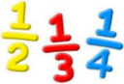

Wednesday, September 8, 2021 12:00 pm

**Factoring**

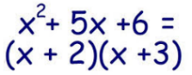

Wednesday, September 15, 2021 12:00 pm

**Graphing Lines**

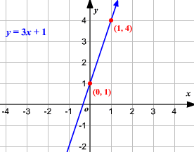

Wednesday, September 22, 2021 12:00 pm

**Writing Equations of Lines**

**y = mx + b**

**Ax + By = C** Wednesday, September 29, 2021 12:00 pm

**Exponents**

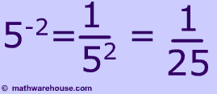 Wednesday, October 6, 2021 12:00 pm

**Factoring**

 Wednesday, October 13, 2021 12:00 pm

Presented by the Academic Support Center.

Please contact Donna at 817.598.6278 or [dcox@wc.edu](mailto:dcox@wc.edu) with questions.

**MATH WORKSHOP WEDNESDAYS**

**FALL 2021**

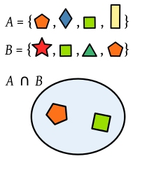**Basic Set Concepts**

Wednesday, October 20, 2021 12:00 pm

**Truth Tables**

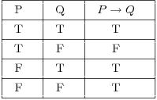 Wednesday, October 27, 202 12:00 pm

**Compound Interest & Investments**

 Wednesday, November 3, 2021 12:00 pm

**Graphs of Basic Functions with Graphing Techniques**

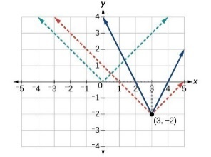Wednesday, November 10, 2021 12:00 pm

**Logarithmic Functions**

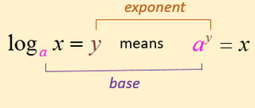

Wednesday, November 17, 2021 12:00 pm

**Factoring**

 Wednesday, December 1, 2021 12:00 pm

Presented by the Academic Support Center.

Please contact Donna at 817.598.6278 or [dcox@wc.edu](mailto:dcox@wc.edu) with questions.